

**COMSATS University Islamabad (CUI)**

Project Proposal  
(SCOPE DOCUMENT)

for

**Habibi**  
Version 1.0

***By***

**Husnain Arshad CIIT/FA16-BSE-152/ISB**

**Muzzamil Arshad CIIT/FA16-BSE-148/ISB**

***Supervisor*Ma’am Najam Un Nisa**

***Co-Supervisor*Dr. Omar Ahmad**

*Bachelor of Science in Software Engineering (2016-2020)*

**SCOPE DOCUMENT REVSION HISTORY**

|  |  |  |
| --- | --- | --- |
| **No.** | **Comment** | **Action** |
| 1 | * What will be the modules and how they will be divided? * What should be the scope of project? | We divided the system into multiple modules and then divided them between us.  The scope of project was decided in a meeting with supervisor. |
|  |  |  |
|  |  |  |
|  |  |  |
|  |  |  |
|  |  |  |

**Supervisor Signature:**

**Date:**

**Table of Contents**

**1. Introduction 2**

**2. Problem Statement 2**

**3. Problem Solution for the Targeted System 2**

**4. Related System Analysis/Literature Review 3**

**5. Advantages/Benefits of the Targeted System 3**

**6. Project Scope 3**

**7. Modules 4**

**7.1 Module 1: Robot Movement 5**

**7.2 Module 2: Object Detection 5**

**7.3 Module 3: Object Recognition 5**

**7.4 Module 4: Collision Avoidence 5**

**7.5 Module 5: App Controller 5**

**7.6 Module 6: User Managment 5**

**7.6 Module 7: Path Generation 5**

**8. System Limitations/Constraints 5**

**9. Software Process Methodology 5**

**10. Tools and Technologies 5**

**11. Project Stakeholders and Roles 6**

**12. Team Members Individual Tasks/Work Division 7**

**13. Data Gathering Approach 7**

**14. Concepts 7**

**15. Gantt chart 8**

**16. Mockups 8**

**17. Conclusion 9**

**18. References 9**

**19. Plagiarism Report 10**

# 

**Project Category:**

* **C-** Problem Solving and Artificial Intelligence
* **E-** Smartphone Application
* **H-** Image Processing
* **I-** Robotics

# Abstract

# Habibi The Robot is an helping Robot for disabled people, to help them in their daily life tasks such as picking up needed things to the user. We are striving to design a part-picking robot that will help the humans to control the device with a smartphone. It will greatly help the paralyzed community as they will be able to access their objects by simply commanding the robot from their smartphones.

# Introduction

# Habibi the Robot is a part-picking robot which has been designed to make things easy and comfortable for humans especially paralyzed or disabled persons. The robot will carry out operations picking light-weight objects and providing the object to the user.

As the paralyzed and **aged people** face difficulty in the movement, they even can’t get up to walk and picking their medicines. They surely need someone’s help to access their objects (glasses, medicines, water). This device will help them a lot. They will be having required routine objects by issuing commands while staying at their location. This robot can also act an assistant to a normal person. It will aid by providing things to a busy person reducing his time, efforts and the frustration.

In everyday issues, a disabled person who is sitting on a wheelchair can’t even stand**-**up to take a glass of water. He surely needs physical help of someone to have a glass of water. Moreover, he cannot stand up and walk to pick up his medicine from the table. This robot will put great efforts to help them. It will be able to walk on different angles. The robot will detect hurdles in its path and will counter the object by adjusting itself according to object’s height and width with user help.

As this robot will fulfill the needs by solving the routine issues, so it will be required in almost every house. This will promote and strengthen our business model.

# Problem Statement

As the people who can’t walk face a huge difficulty in picking up their desired objects, needed a solution to their problem, we are making Habibi The Robot for their specific problem of Object Picking. This system solves the problem of paralyzed and disabled persons. It will help disable people , it carry different light weight objects(water, glasses , tablets).

There are already many robots available in international market but not nationally in Pakistan, also they are found to be very costly, so the main purpose to develop Habibi the Robot is to make it nationally available in the commercial market at a very reliable cost, as with the re-implementation of this system, we are going to enhance our capabilities by learning Arduino/ Raspberry Pi with React Native Android, iOS and Web development, we will also learn Project management, Technical development skills , Testing strategies for hardware based system.

# Problem Solution for the Proposed System

The disabled user who is not able to walk, will be able to control Habibi The Robot with an Android/iOS/Web App. The System will move in different directions picking-up light weight objects on the user command and providing those objects to the user. It will also alert the user if Habibi the Robot is stuck in some hurdle, and will wait for the next user command accordingly,

It will be programmed to carry out specific tasks at specified time without any user interaction for paralyzed community. For a normal user, Habibi the Robot will be to control it manually by giving commands from smart application.

# Related System Analysis/Literature Review

Table 1: Related System Analysis with Targeted Project Solution.

|  |  |  |
| --- | --- | --- |
| **Application Name** | **Weakness** | **Proposed Project Solution** |
| * Amazon Robot (Nova Wonders) | * Highly Costly. * Not available in Pakistan | * Habibi the Robot will be cost efficient * Will be available nationally in Pakistan. |
| * [Edgefx Kits](https://www.elprocus.compick-n-place-with-soft-catching-gripper/) Robot | * Highly Costly. * Robot is only to pick objects from floor. | * Habibi the Robot will be cost efficient * Will be able to pick objects from a height of table. |
| * LearnObots (Pickdroid) | * Can only be controlled by android phone with in same Wifi. | * Habibi the Robot could be controlled by Android, iOS, Web App anywhere in the world with an available internet connection. |

# Advantages/Benefits of Proposed System

* System will help disable people.
* Daily life tasks will be easy to do, as user won’t need to remember things.
* Interfaces of the system will be very simple.
* Easy to use.
* If this system is implemented nationally, it will Boost the Pakistani economy.
* Habibi the Robot will be one of the most cost-efficient robots in its domain.
* Habibi the Robot will increase the safety of the working environment and never get tired.

# Project Scope

System will support disable and normal people. The system will be used to pick and place things. It will provide a complete help to pick and place light things(tablets, water, glasses ).

The user will provide the required information to the system. The system will authenticate the user. The entrepreneurs will also be able to use it manually according to their need.

# Modules

## Module 1: Robot Movement

System will move on a specific path which is saved in a system or you can drive a robot manually as well through the App. The Robot will move left, right, reverse, and towards front.

The Arm of the robot will move in a 360 degrees rotation.

## Module 2: Object Detection

The Robot is going to detect the objects present in the camera view and move accordingly.

## Module 3: Object Recognition

System will use image processing to recognition the objects, a camera will be placed in the robot and it will do the image processing to recognize what the object is.

## Module 4: Collision Avoidance

Infra-red sensors will be placed on all the sides of the Robot to make it collision free, the sensors will measure the distance from obstacles and will send the information to the CPU board to make further decision.

## Module 5: App Controller

An Android, iOS and Web App will be made to control the Robot, this app will the following functionalities:

* Camera View: The App will show the view from the camera in real-time, and user will touch on the object to pick up.
* Robot Movement Buttons: There will be 4 buttons to move the robot forward, backward, left, right.
* Robot Switching on off Buttons.
* Battery Indicator.
* Add, Delete, Edit Task: The user can add a task to robot which it will perform everyday, once a week, or daily.
* Alerts

## Module 6: User Management

User management is a Database which will store all the data of the users for future use and decisions.

## Module 7: Path Generation

Path generation will provide the robot a path to follow to reach the desired location to perform the assigned task, and come back to the user.

# System Limitations/Constraints

* System can be used only for light weight objects.
* Habibi the Robot will only be designed for indoor environments.
* The developed system can be used only in a visible environment.
* The user must have a smart-phone or a laptop to operate the robot.
* The Movement of the robot will be possible on a smooth surface.
* High Power-to-Weight Ratio.
* It will operate Within wi-fi signal.
* Will not operate on stairs

# Software Process Methodology

For this project we follow the standard agile model used mainly for android, iOS web

-based applications. The agile method includes the following phases:

1. Planning: In this phase all the goals and objectives for the project are determined and set for successful completion of the project.
2. Requirement Analysis: No clients are assigned to our project, so we consult our supervisor after we develop a requirement for our project. He then analyzes and approves/rejects it.
3. Design: Our design will be based on the software design our application has keeping in mind the requirements outlined.
4. Coding: On completion of the design phase we will move to development and start coding. Once development of the game has been completed on both android, iOS and web platforms we will move to testing.
5. Testing: A test plan and test case will be developed, and the final project shall be tested accordingly.
6. Documentation: In documentation phase we involve all the written documents and material concerns with our project development.

# Tools and Technologies

Table 2: Tools and Technologies for the Targeted Project.

|  |  |  |  |
| --- | --- | --- | --- |
| **Tools**  **And**  **Technologies** | **Tools** | **Version** | **Rationale** |
| Microsoft Windows | 10 Home | As Operating System |
| Arduino | Updated Version | Robotic Circuits |
| Raspberry Pi | Updated Version | Robotic Circuits |
| React Native Snack | Updated Version | Web IDE |
| React Native Expo | Updated Version | IDE |
| Google Firebase | Updated Version | DBMS |
| Adobe Photoshop | Updated Version | Design Work |
| MS Word | Updated Version | Documentation |
| MS Power Point | Updated Version | Presentation |
| Pencil | Updated Version | Mockups Creation |
| **Technology** | **Version** | **Rationale** |
| React Native | Updated Version | Android/ iOS/ Web Development |

# Project Stakeholders and Roles

Table 3: Project Stakeholders for the Targeted Project.

|  |  |
| --- | --- |
| **Project Sponsor** | ***COMSATS University Islamabad*** |
| **Stakeholder** | * Student: Husnain Arshad * Student: Muzzamil Arshad * Project Supervisor Name: Maam Najam Un Nisa. * Co Supervisor: Dr, Omar Ahmad * Final Year Project Committee: Evaluation of project |

# Team Members Individual Tasks/Work Division

Table 4: Team Member Work Division the Targeted Project.

|  |  |  |
| --- | --- | --- |
| **Student Name** | **Student Registration Number** | **Responsibility/ Modules** |
| * ***Husnain Arshad*** * ***Muzzamil Arshad*** | * ***FA16-BSE-152*** * ***FA16-BSE-148*** | * ***Husnain Arshad (Module1-Module3)***      * ***Muzzamil Arshad (Module2-Module4)*** |

# Concepts

In this Final project we will learn these following things below:

* Embedding Software into Hardware.
* Raspberry Pi
* Arduino
* React Native Expo
* React Native Snack
* Google Firebase
* Adobe Photoshop

# Data Gathering Approach

In this we will first approach the domain expert of this type of system to thoroughly understand the functionality of this proposed system. For this we will also prepare some basic prototypes, use cases and class diagrams for the further discussions in the interviews for the better understanding of this proposed system.

# Gantt chart

# Mockups

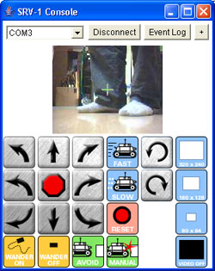

Figure Interface of Application

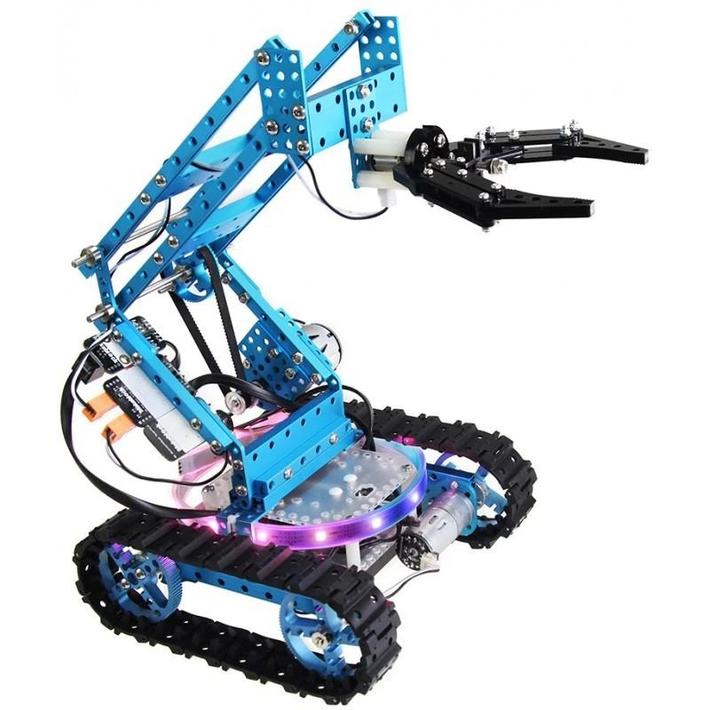

Figure 2: Habibi the Robot

# Conclusion

# As the project progress and we move towards completion, we will have a complete know how of robotic development, web Android and iOS app developments, software hardware interactions. This System will be a good opportunity for the disable people from all over the Pakistan. It will give a basic platform for both normal and disable people. Through this the main thing is that the System will aid the old age and paralyzed community. It will also have a big contribution in moving Pakistan towards success.

# References

* 1. <https://www.toytag.com/products/makeblock-ultimate-2-0-stem-educational-robot-kit>
  2. <https://learnobots.com/mearm>

* 1. <https://amazon.com/NovaWonders>
  2. <https://www.electroschematics.com/author/edgefx/>

# Plagiarism Report

